Ideation Phase
Brainstorm & Idea Prioritization

Date | 30/10/2025
Team ID | NM2025TMID07186
Project Name | Streaming Ticket Assignment System For Efficient Support Operations
Maximum Marks | 100 marks

Step-1: Team Gathering, Collaboration and Select the Problem Statement

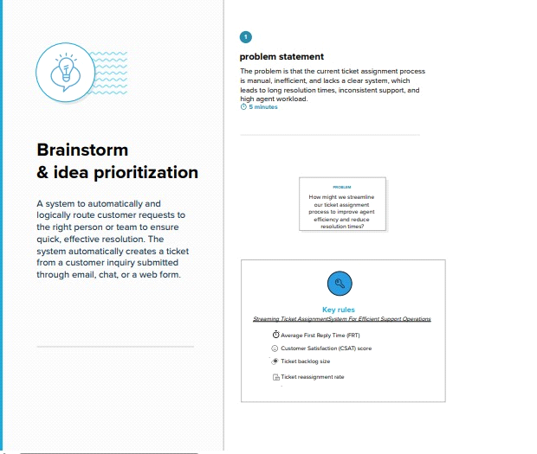

Step-2: Brainstorm, Idea Listing and Grouping
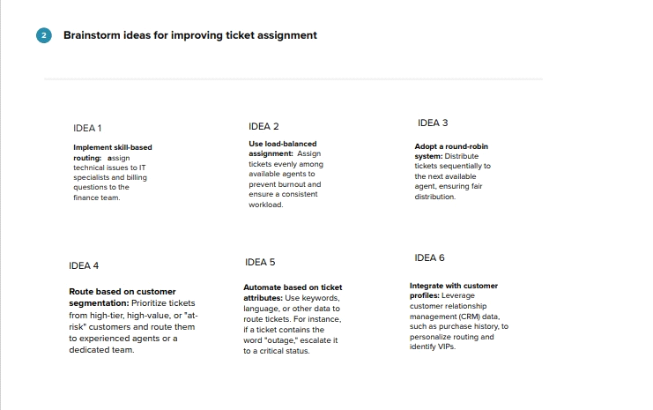

Step-3: Idea Prioritization
